JWT Authentication Analysis and Token Management Study

As part of the web application security assessment, the authentication and authorization mechanisms of the Flashyre platform were analyzed using browser Developer Tools. The objective of this testing activity was to understand how the application communicates with the backend server, identify authentication-related API requests, and investigate the possible use of JWT tokens, token lifecycle management, refresh tokens, and token rotation mechanisms.
To perform this analysis, the Network tab of the browser Developer Tools was used to capture and monitor HTTP requests and responses generated by the application during user login and normal application usage. This process helps in understanding the application's authentication workflow and security implementation.

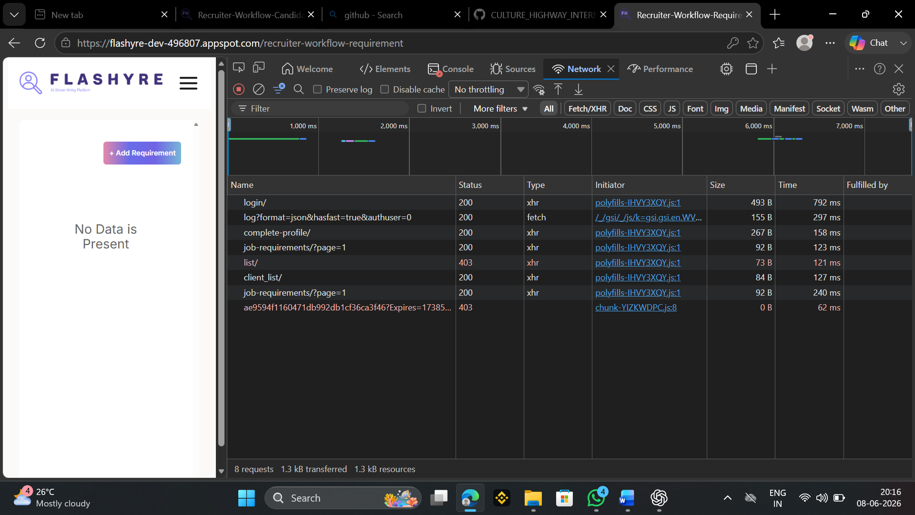

Network Traffic Analysis
The Network tab in the browser's Developer Tools was used to analyze the communication between the client and server. During testing, several API requests such as login, complete-profile, client_list, and job-requirements were observed. The status codes of these requests were examined to understand the application's behavior.
Observation: Multiple authenticated API requests were identified. Further inspection of request headers, response data, and browser storage is required to determine whether JWT authentication, refresh tokens, and token rotation mechanisms are implemented in the application.

JWT Authentication and Token Storage Analysis Report

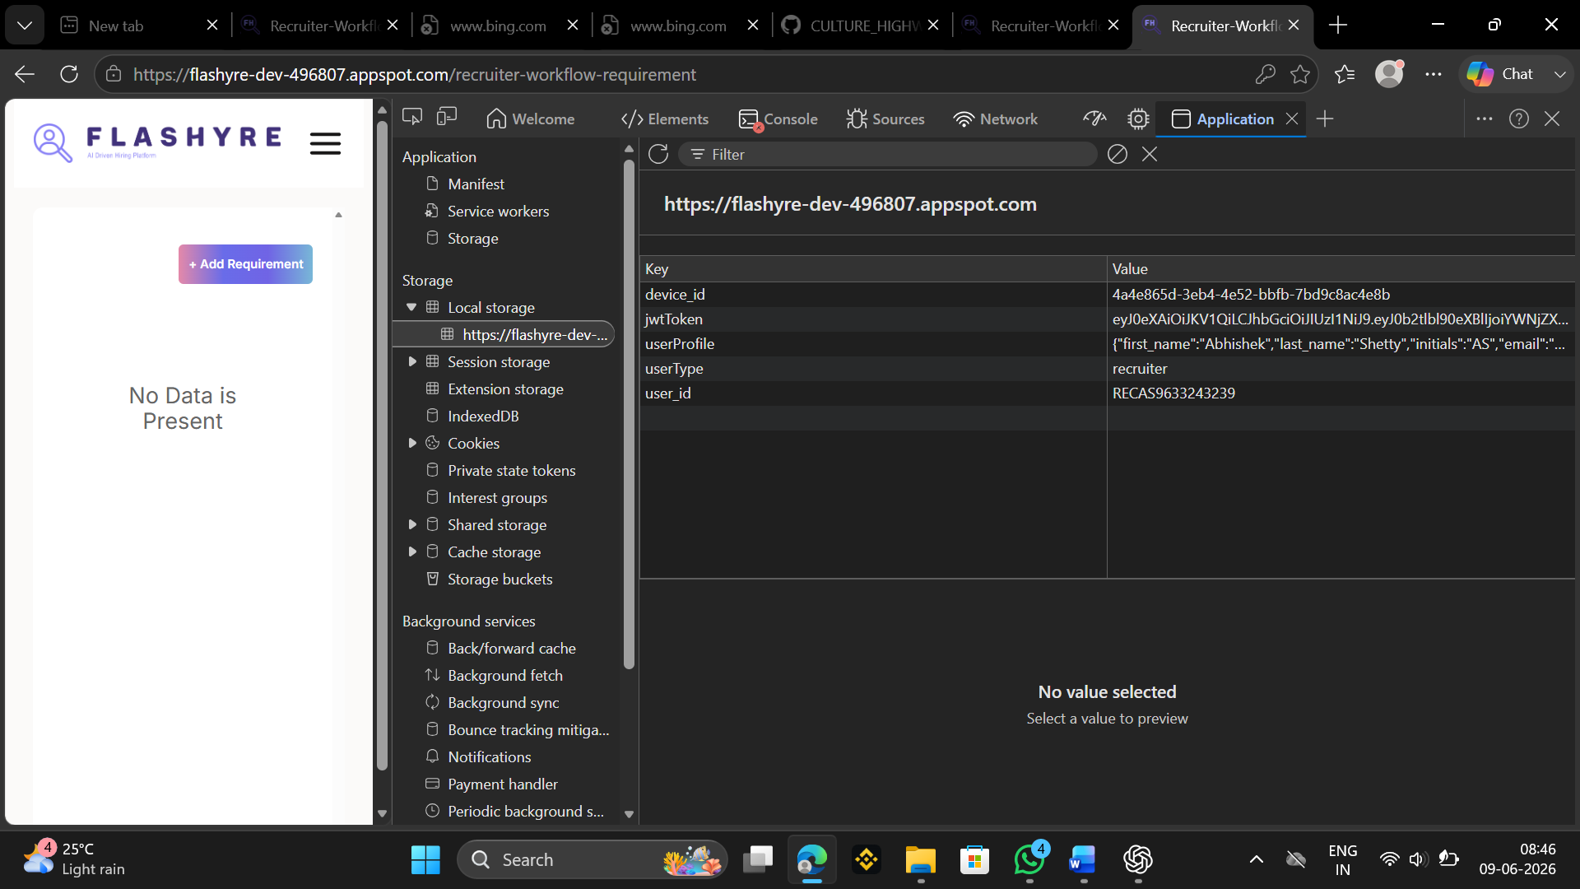

During the assessment, the browser's Developer Tools (Application Tab) were used to inspect client-side storage mechanisms. The analysis focused on identifying authentication tokens, storage locations, and the security mechanisms implemented by the application.
The application under assessment was observed storing authentication-related information within Local Storage.

Findings
1. JWT Token Detected
A JSON Web Token (JWT) was identified in the browser's Local Storage under the key:
jwtToken
The token value began with:
eyJ0eXAiOiJKV1QiLCJhbGciOiJIUzI1NiJ9...
The structure confirms that the application uses JWT-based authentication.

2. JWT Algorithm Identified
The token header indicated the following configuration:
{
"typ": "JWT",
"alg": "HS256"
}
Analysis
- Type: JWT (JSON Web Token)
- Algorithm: HS256 (HMAC SHA-256)

The assessment confirmed that the application uses JWT (JSON Web Token) based authentication. The JWT token was successfully identified and found to be stored in the browser's Local Storage under the key jwtToken. Analysis of the token header indicated the use of the HS256 signing algorithm. User-related information such as user profile, user type, and user ID were also stored in Local Storage. Further testing is required to verify token expiration, refresh token implementation, token rotation, and logout session invalidation mechanisms to fully evaluate the application's token lifecycle and authentication security.

